# TORITO CHEMICAL

## OCTOBER 9 – OCTOBER 28

|  |  |  |
| --- | --- | --- |
| What is needed to complete this objective | Objective | What will be done with this objective? |
| Understanding of MATLAB code for the injector | Determine inlet specifications to the injector plate including Temperature, pressure, mass flow rate of fluids |  |
| Mass flow rate through combustion chamber might give us idea of total mass flow rate in the liquid state | Analyze O/F ratios [T_0 / m] Ratio in NASA CEA |  |
|  |  |  |

Resources

1. [List_of_Resources_Torito_Propulsion_1.xlsx](https://usfedu.sharepoint.com/:x:/r/teams/SocietyofAeronauticsandRocketryGRP/Shared%20Documents/Torito/General%20Resources/List_of_Resources_Torito_Propulsion_1.xlsx?d=w736ca2f03df743fca9f9cdf88ed25944&csf=1&web=1&e=UNoUgV)

2. [Sizing Orifices of an Injector](https://www.shawnvictor.net/injector-orifice-sizing.html)

3. [NASA CEA](https://cearun.grc.nasa.gov/)

4. [Example Design Calculations for Orifice](https://risacher.org/rocket/example.html)

5. [USF SOAR GITHUB](https://github.com/usfsoar)

# Sizing Orifices of an Injector

## 1.0. Variables

* Need to know
  + What are your propellants
  + Upstream pressure of the propellants
  + Overall thrust you are trying to achieve
* Useful Tool
  + [NASA CEA](https://cearun.grc.nasa.gov/) - helps with the intensive thermodynamics and chemical mathematics

## 2.0 Example Google Sheet

## 

## 3.0 Using NASA CEA

## 3.1 Determine total mass flow rate

## 3.2 Input combustion chamber pressure (Units: PSIA)

* Determine tank holding pressure aka "run tank"
* In an ideal case
  + Pressures loses in our feed system are negligible ie. they compromise ~ 1% loss
* Downstream pressure (combustion chamber) needs to be half of the pressure located on the input side of the injector plate
  + This ensures that flow does not go backwards (choked flow)
  + Personal thought: If we know the combustion chamber pressure through RPA, then we can multiply by 2 and determine? Keep in mind volatility of the propellant though when making this decision

## 3.3 Choose your fuel and oxidizer

## 3.4 Submit input and Perform CEA Analysis

## 3.5 Consider melting point of chosen material

* Check that NASA CEA results for engine temperature well below melting point of material
* Use a factor of safety of 1.5 or greater
* Equation: (Melting Point of material / 1.5) and then round down.
  + Output: Desired Maximum temperature of our engine

## 3.6 Oxidizer to Fuel Ratio

* Stoichiometric Ratio
  + Highest point of temperature
  + Just enough oxidizer to mix with all the fuel needed
* Oxidizer in Excess
  + Temperature decreases
* The more wasted propellant => propellant has the potential to add more energy to the system through combustion but it just exhausted out the nozzle => less efficient engine
* Higher temperature => more efficiency
* Note:
  + We are more constrained to melting point of material rather than ability to have combustion at the stoichiometric ratio

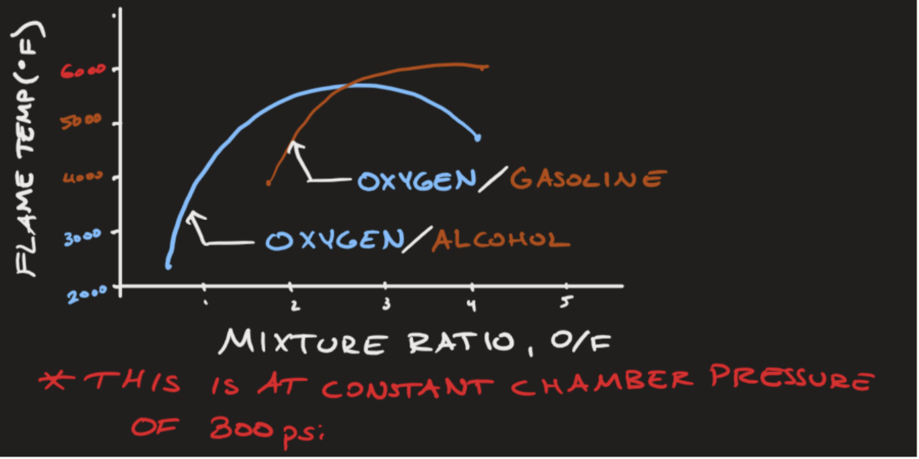

## 3.7

* Run NASA CEA data to see (i) O/F Ratios and (ii) Chamber Temperatures
* Look for O/F Ratios to see how close you can get to the Maximum Determined Chamber Temperature
  + Remember, this must be the lower bound of the melting point of the material